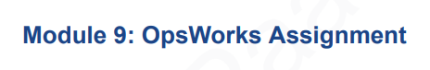

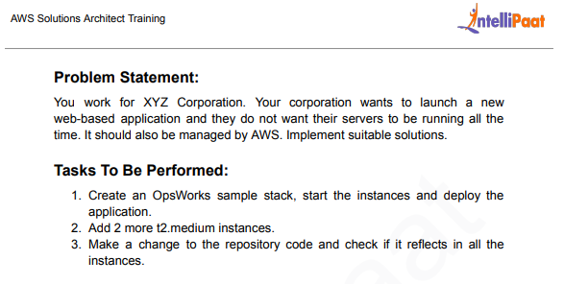

1. Go to Console Serarch AWS OpsWorks, it will trigger to Opswork Page. Creating OpsWorks Sample Stack

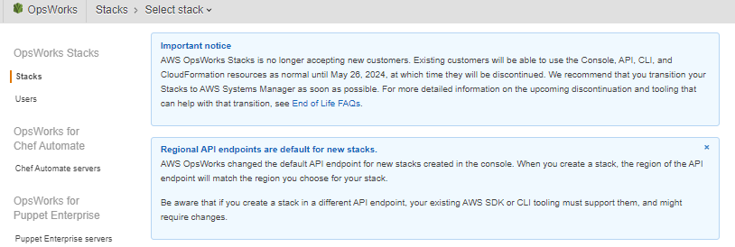



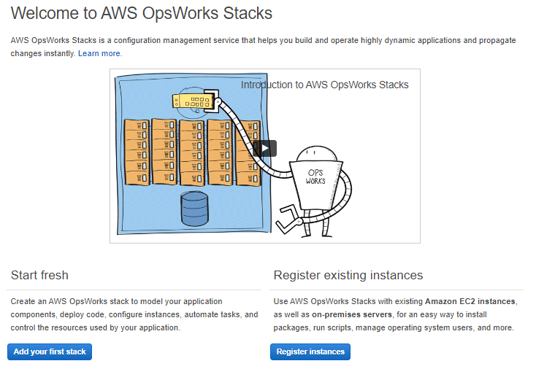



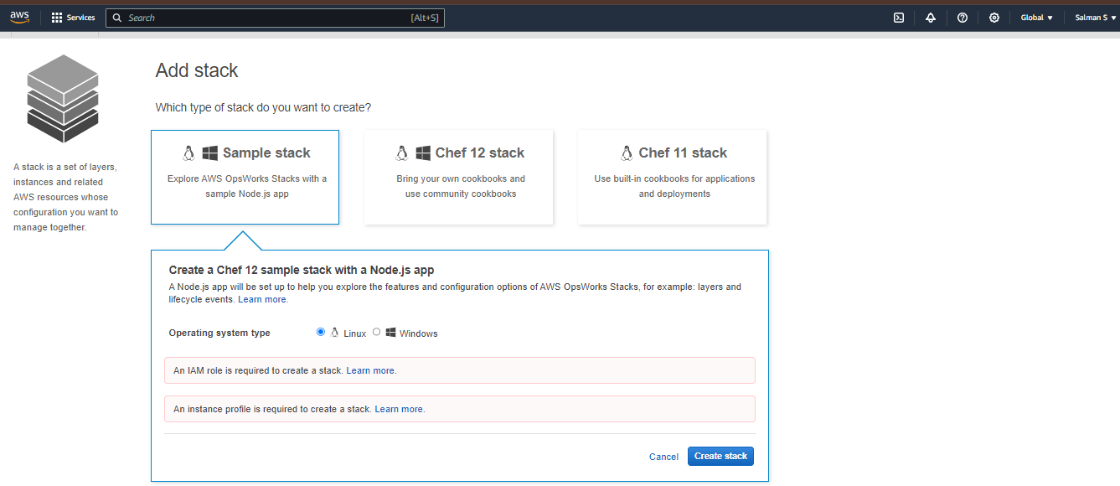



So Need to Create a EC2 instances and IAM Role

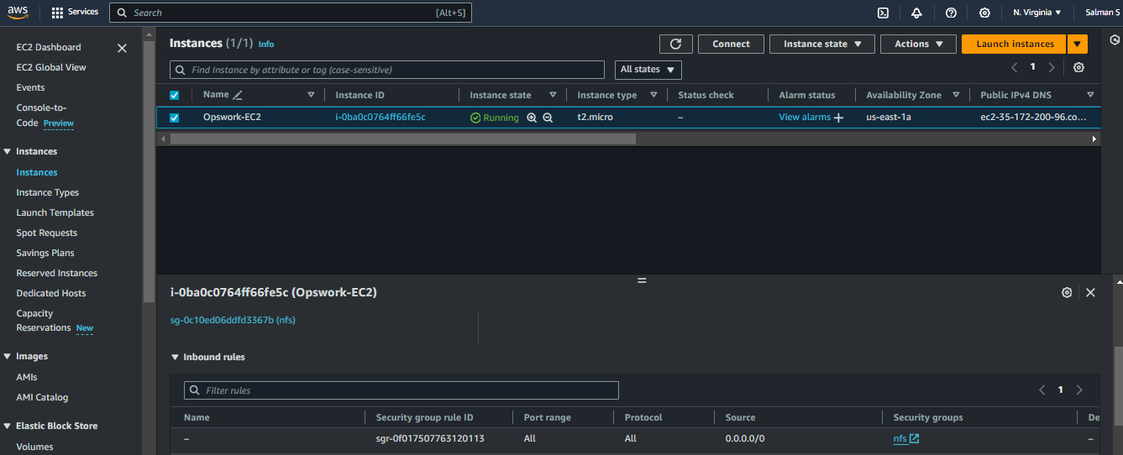



No IAM Role Created

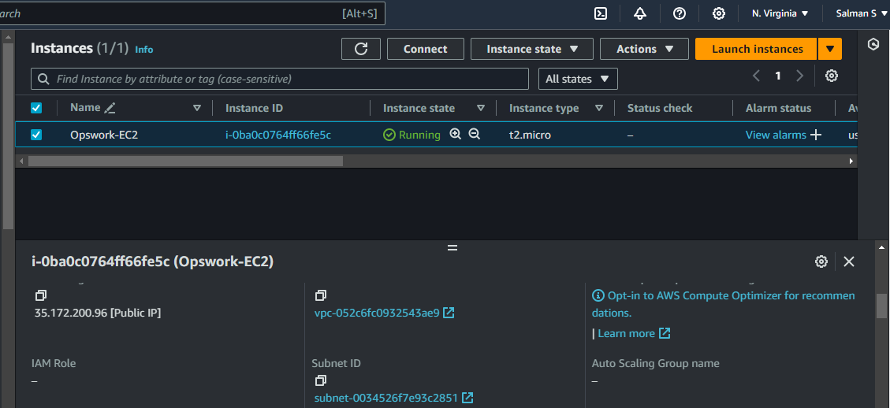



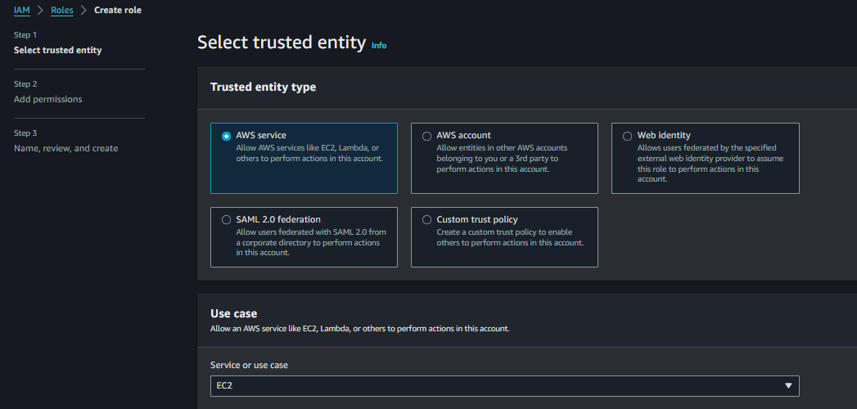



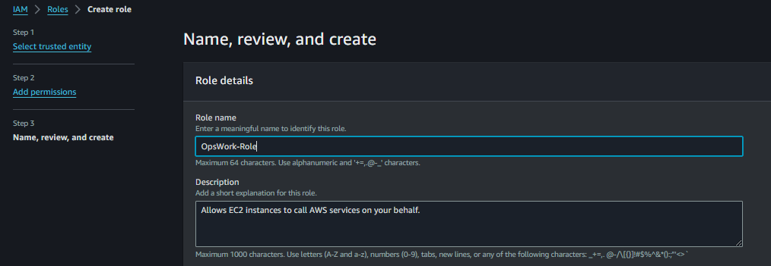



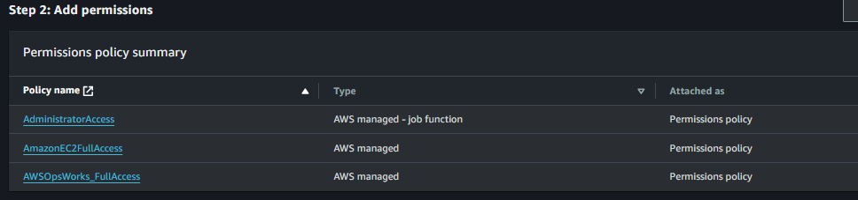



Go to Created Instances and Attach IAM Roles and Update

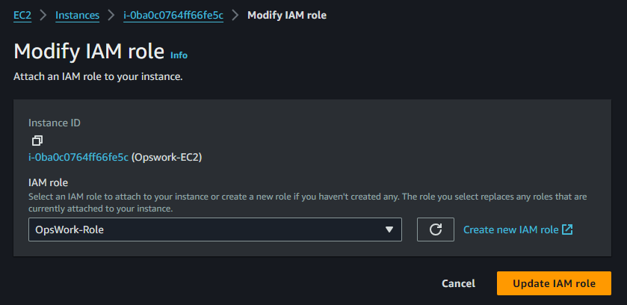



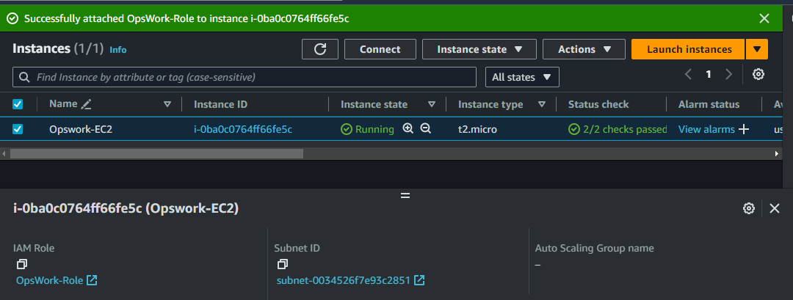



Go To Opswork Page and Refresh it, Creating a Sample Stack Selecting Linux Machine and Click Create Stack

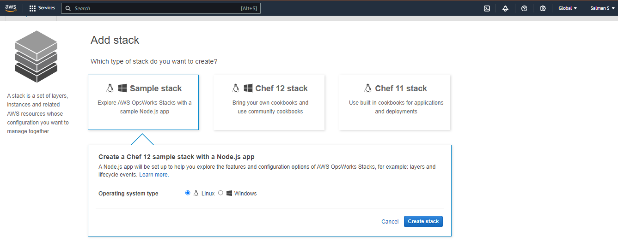

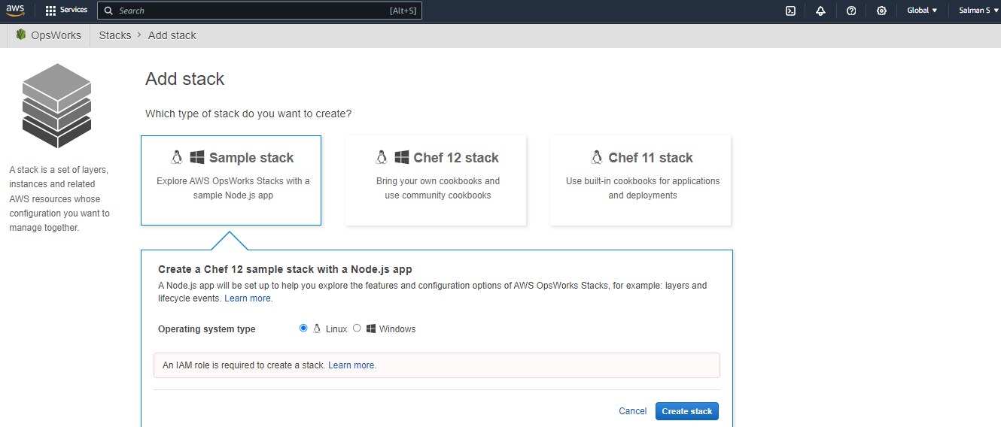



We Created IAM Role, Now we are going to Create with Chef 12 Stack and Default IAM Selected but still asking to required IAM Role

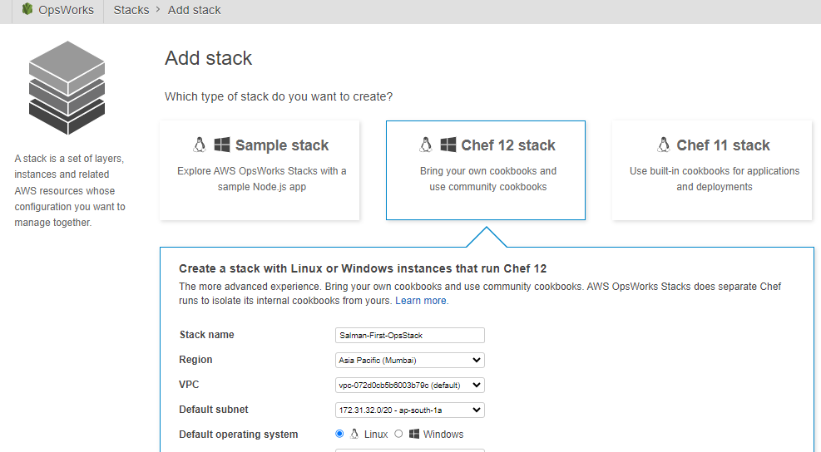



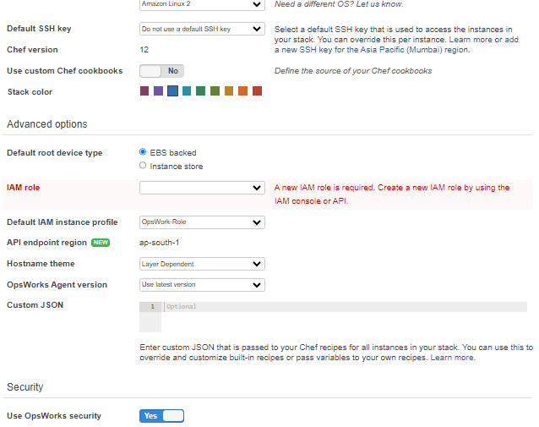



Maybe Because of this reason, I don’t exactly but not able to create a stack eventhough I created IAM role

Note: This Opswork Not Covered to us

